

**CG1112 Engineering Principle and Practice**

Semester 2 2017/2018

**“Vincent to the Rescue”**

**Design Report**

**Team: XX-YY-ZZ**

<Remember to save this report as XX-YY-ZZ.docx, where XX-YY-ZZ is your project team number>

<Think about how to split your teams into sub-teams, i.e. software, firmware, hardware. It is also a good idea to have a nominal team/subteam lead.>

|  |  |  |  |
| --- | --- | --- | --- |
| Name | Student # | Sub-Team | Role |
|  |  |  |  |
|  |  |  |  |
|  |  |  |  |
|  |  |  |  |
|  |  |  |  |
|  |  |  |  |

<Remove these notes in the actual report>

The main aim of this report is to **explain your ideas and designs.** Make sure the reviewers have enough details to give you feedback and advice.

The report will be graded based on:

1. Quality of information.
2. Quality of design: Clearly thought through, makes logical sense etc.

</Remove in actual report>

**Section 1 System Functionalities**

<Remove this in actual report>

Describe the intended system functionalities**.** This is for us to gauge your understanding of the project specification.

You are free to use any method to describe the desired system functionalities, including picture / diagram / drawing. Try to be as succinct as possible.

</Remove this in actual report>

**Section 2 Review of State of the Art**

<Remove this in actual report>

Before embarking on a project, we need to know the state of the art. Sometimes, you may even find that the problem has already been addressed!

Give the following for **one tele-operating** and **one autonomous** search and rescue robotic platform:

1. Simple description of the system, focus on the functionalities, hardware / software component.
2. Summary of strength and weakness.

**We expect no more than 1 page of information in total** forthis section. You can include photos / diagrams if appropriate.

</Remove this in actual report>

**Section 3 System Architecture**

<Remove this in actual report>

Use a diagram or similar to illustrate the high level components of Vincent. Among other things, indicate clearly:

* 1. Software components to be implemented on the Raspberry Pi and the Arduino.
  2. Additional hardware components, e.g. Lidar, motor, etc. indicate clearly the connection between them.

As an example, below is a partial diagram depicting the mBot from CG1111:

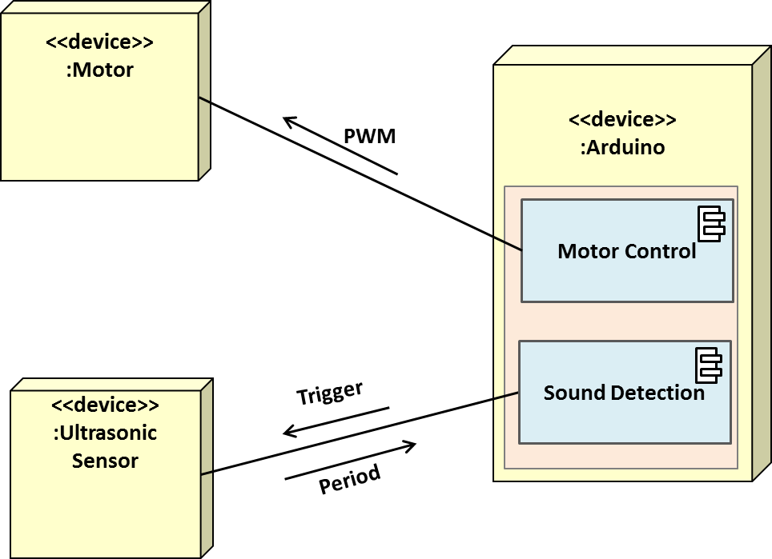

The yellow square boxes represents hardware, blue boxes represent software. The connection between the components can contain information / control passes between them.

Note: this is a simplified ***UML deployment diagram*** if you want to learn more.

Note2: A powerpoint slide containing the drawing is provided to simplify your work.

</Remove this in actual report>

**Section 4 Component Design**

<Remove this in actual report>

Please give:

1. A high level algorithm describing the steps needed to solve the problem.
2. Expand the more complicated steps separately. Indicate clearly the information (data), hardware components involved in the step if appropriate.

Below is a partial example.

*High Level Steps:*

1. *Initialization*
2. *Receive user command*
3. *Carry out command*
4. *Repeat step 2 until navigation is over*

*Further breakdown:*

*Step 1. Initialization (*

1. *Pi preforms handshake with Arduino by sending "Hello There" (just an example).*
2. *Arduino replies with "You looks good today".*
3. *Pi asks Arduino for an initial reading of the environment.*
4. *etc*

*Step X………*

*Step Y………*

</Remove this in actual report>

**Section 5 Project Plan**

<Remove this in actual report>

Give a brief timeline (weekly will do) of your internal deliverables and milestones. Try to align with the tentative evaluation timeline to make sure you have enough time to meet all CA requirements.

</Remove this in actual report>

**Reference**

<Remove this in actual report>

List all references here.

</Remove this in actual report>